**Perform CRUD operations**

Application to perform the following operations

1. C 🡪 Inserting
2. R 🡪 Reading
3. U 🡪 Updating
4. D 🡪 Deleting

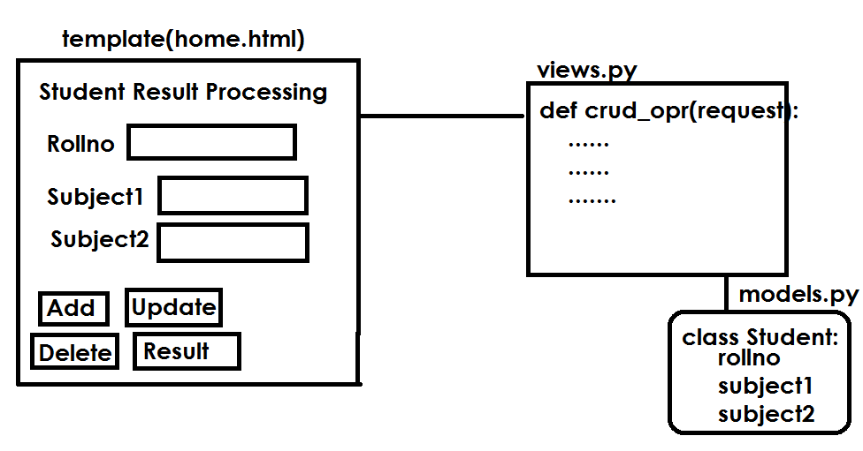

**Request methods**

1. GET
2. POST

POST request is to perform operations which do changes at server side. Inserting, updating, deleting

GET request is used to read information from server. This request does not do any changes at server

request.GET[‘parameter-name’]

request.POST[‘parameter-name’]

request.GET.get(‘parameter’)

**QueryDict objects**

In an **[HttpRequest](https://docs.djangoproject.com/en/4.0/ref/request-response/" \l "django.http.HttpRequest" \o "django.http.HttpRequest)** object, the [**GET**](https://docs.djangoproject.com/en/4.0/ref/request-response/#django.http.HttpRequest.GET) and [**POST**](https://docs.djangoproject.com/en/4.0/ref/request-response/#django.http.HttpRequest.POST) attributes are instances of **django.http.QueryDict**, a dictionary-like class customized to deal with multiple values for the same key. This is necessary because some HTML form elements, notably **<select multiple>**, pass multiple values for the same key.

The **QueryDict**s at **request.POST** and **request.GET** will be immutable when accessed in a normal request/response cycle

QueryDict object contains request parameters or request string. The values send by client to server.

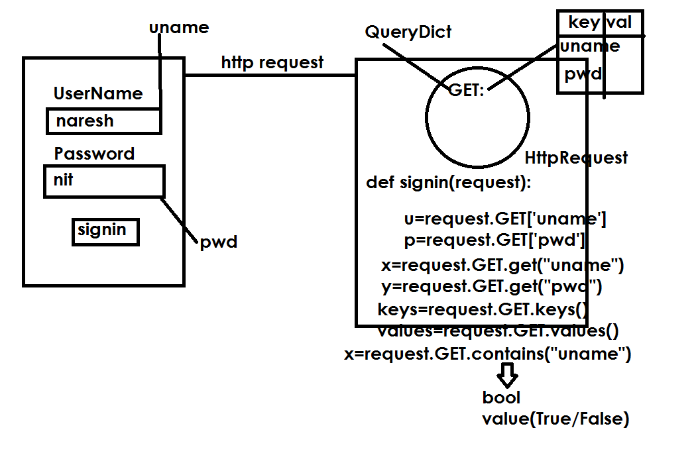

**Student Result Processing**

1. Create a project

django-admin startproject crudproject

1. Create application within project

python manage.py startapp crudapp

1. models.py